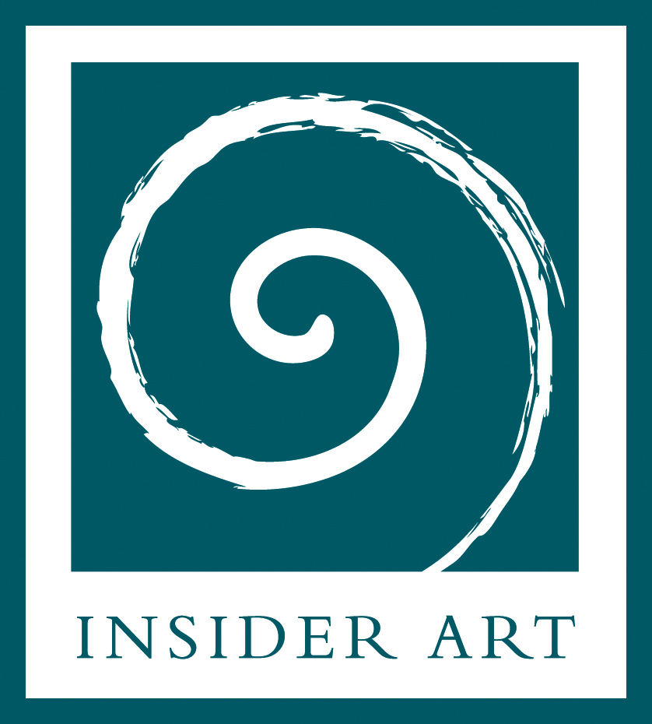
Art in Health
Practical Applications:

For 2015
Our Art in Mental Health, Art Therapy Foundation course is complemented by an intensive practice based third term which explores practical applications of psychologically and emotionally informed art making with others. Though influenced by art psychotherapy understandings and practice, this course is not a therapy training: it seeks to develop more people-skilled, informed, confident and effective Arts & Health practitioners.
To qualify in Art Therapy requires M.A. level training: an art therapy foundation course is strongly recommended for those considering this route.

Former students seem to be significantly advantaged by attending both Foundation and the practice based courses. Completing the Insider Art, or other equivalent, Foundation level course is an entry requirement. (Please contact us to discuss equivalent courses.)

The course aims to:
- Introduce and develop understanding of ways that participatory visual arts are used in health, education, voluntary sector and community contexts to enhance wellbeing
- Improve cooperative working by understanding the concerns, languages and priorities in different institutional/organisational contexts. Recognise implications for artists/ facilitators working with various health problems.
- Develop awareness of the potential influence of art making on positively enhancing mental health, self-esteem, resilience, and well-being. Understand how ‘health’ work also implies understanding and working with the vulnerability, distress and anxiety bereavement, loss and recovery that may be encountered.
- Explore the benefits and pitfalls of exhibiting work. Consider implications of working with different media and materials.
- Introduce ideas from group dynamics, emotional literacy, art psychotherapy and health psychology which help inform good arts practice and effective ‘helping relationships.’
- Provide grounding in ethical issues and legal responsibilities eg: Duty of Care. Explore factors which underpin safe, effective practice eg: risk assessment, managing boundaries, clear negotiation and ‘contracts’ with organisations and participants.
- Enhance appreciation of, and skills in, “hidden” success and sustainability factors like stress management, reflective practice, personal and professional self-care and support.
- Improve student employment prospects by increasing their confidence, understanding and ability to articulate the issues involved in effective Arts & Health work.

Who is the course for?
Previous students on our practice based courses have included youth workers, health professionals, classroom support and play therapy workers, teachers and artists, many were funded by their workplaces to attend. As the course is work based and emphasises reflective practice students need to be engaged with an on-going, appropriate arts project. Some students have negotiated placements as volunteers or assistants at after school clubs, ‘messy church’ groups, Age Concern or Mind art groups etc for this purpose.

Who teaches it?
Karen Huckvale is an experienced and qualified Art Psychotherapist, Health and Care Professions Council registered. (hpc-uk.org.uk) Karen was a founder Trustee of Arts & Health South West. She is Art Psychotherapist for Devon NHS Child and Adolescent Mental Health Service. A skilled mentor to Arts & Health project workers and to artists, Karen also supervises arts projects and clinically supervises therapists, counsellors and trainees from a range of disciplines. Karen delivers Insider Art’s environmental and community projects, leads the Practical Introduction to Sandtray Therapy course and co leads the Foundation in Art Therapy. Her background is in Art Education. She has made several important contributions to the professional literature.
Sara Hurley,
Sara is an independent Storyteller and Educator working in partnership with arts, education, health and community organisations. Since 2012 she has led ‘Giants in the Forest’ for Key Stage 2 children from North Devon schools. She is an experienced performer and group facilitator with long experience of developing communication skills in health, education and business environments. As a director of combined arts company Blazing Tales (blazingtales.co.uk) she has led several arts and health projects exploring the experience of being mixed-race in a rural area. Sara has worked with Insider Art over many years and completed their Foundation Course in Art Therapy. Karen and Sara will be supported by visiting speakers.

What qualification will I gain?
A Continuing Professional Development (CPD) Certificate confirming 33 taught hours/ 24 private study hours is awarded to students with over 75% attendance who complete the written work. There are no nationally recognised qualifications at foundation level in the Arts Therapies or the Arts & Health. Insider Art are well recognised trainers and activists nationally – but particularly in the South West - delivering courses for over 15 years and training hundreds of people.

Practicalities
- The student group is small: between 8 and 12 students.
- Some reading is essential. Several short written pieces (3500 words total) are required.
- All materials are provided.
- Learning is through a series of talks, visual presentations, written materials and participatory groups. Each topic is explored from a variety of perspectives.
- Runs: For six Tuesday evening single sessions (6.15pm – 8.45pm) and three Saturday double sessions (10:00am to 4:00pm) in three blocks:
  - March 17th, 21st Saturday & 24th (4 sessions)
  - April 28th, May 2nd Saturday 5th (4 sessions),
  - June 23rd, 27th Saturday & 30th (4 sessions).
Please note these dates are around Easter and May Bank Holiday.

How do I apply?
Applications are accepted from January 5th until 20th February 2015. For an application form email insiderart@blueyonder.co.uk up until Jan 5th and info@insiderart.org.uk afterwards.

What does it cost?
Employer funded: £475.00. Self-funded: £400.00. Concessionary places £350.00. Priority is to students/unemployed applicants, but other low waged applicants are considered. Discount rate: £375.00 for former students of Insider Art’s Foundation course and staff of registered charities.

This course includes education about therapeutic approaches. This inevitably provokes some personal resonances and draws on some personal experiences. However the course is educational and isn't a substitute for personal therapy.
We cannot offer concessionary places to organisations. We will assist applicants where we can to obtain funding/ support from their employers or charitable sources.

