Delegate Feedback

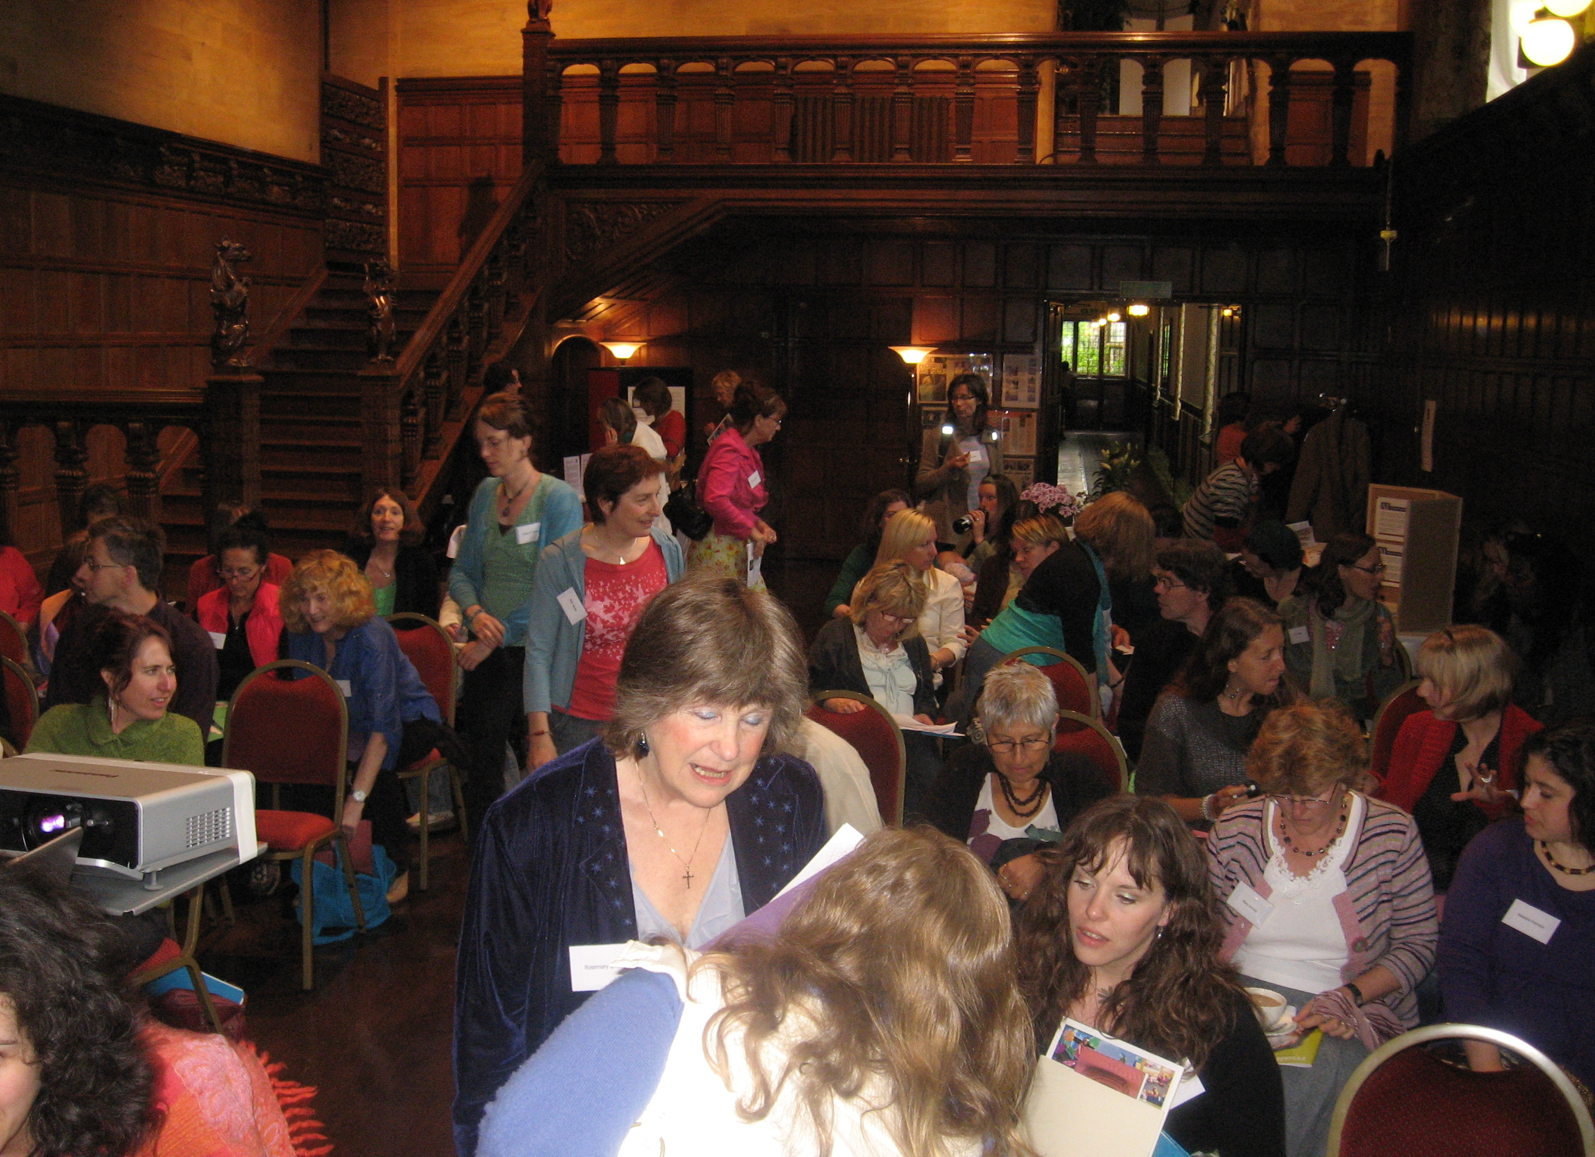

It was all extremely relevant. The focus on various types of relationship was illuminating.

Very relevant in relating the arts therapies to artists and to arts and health practitioners.

Great in these turbulent times to meet minds who think similarly and good to network with new people.

So helpful to meet other like minded people with the same eagerness who are encountering the same struggles.

Inspirational! My thoughts are sparking like a firework display.

The conference was well structured, bound and held together, in a beautiful setting. Such a well orchestrated day.

Most interesting and stimulating. What a wealth of experience joined us today with fascinating insights.

The combination of presentations, variety of perspectives, interweaving of art, therapies, visual languages and falconry was an inspiration.

The best conference/CPD I’ve had since last years conference!

I will take away peoples enthusiasm and encouragement.

I found the links between each talk so useful.

Very thought provoking and interesting to see/ hear such variety of input from various disciplines each addressing common issues within culture, nature, creativity and the arts.

An amazing conference – I feel renewed by it. Thank you so much.

It was full of variety, richness and wonderful examples of inspiring practice.

I found it most useful to be reminded of the need to stay connected to nature.

Peter Randall page’s work is awesome, amazing and profound in its simplicity and its complexity. It perfectly fitted with the subject matter of the day.

I found Maggie Crosbie’s sound advice regarding setting up this kind of project most useful and I loved the birds.

I liked the astonishing correlations between John Wright’s adolescent boy and Merlin the Owl!

Fascinating to think about attachment through teddy bears and owls!

I loved the band, their music was great and I’d have loved to dance to it! But it was a bit too loud which made conversation a bit difficult at times.

It was my first conference with you and I hope to attend your next conference!

I really appreciated the low costs. Thank you.

Thank you for arranging a free taxi service from the station, so helpful.

It was a real treat, thought provoking talks and a delicious lunch I felt very nourished by the whole experience.

An excellent conference, very civilized and stimulating.

The talks, the venue, the people, the refreshments and the location were all fantastic – just a shame about the weather!

Nature & Nurture. 7th Exeter Arts & Therapies Conference. 2008

