

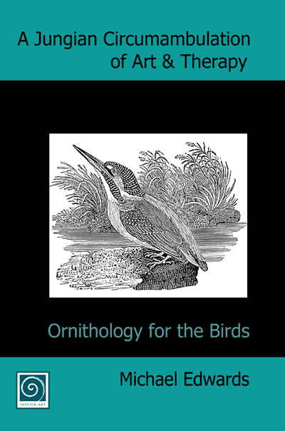

A Jungian Circumambulation of Art & Therapy: Ornithology for the Birds by Michael Edwards

Michael Edwards was an originator, innovator, activist and educator, playing a central role in the evolution of art therapy. This book of previously unpublished papers is the most substantial record of his thinking in the literature.

‘Michael Edwards spoke passionately about the centrality of art in the work and the nature of the work as “this great adventure, as it truly is ..”’
Chris Wood: Director, Art Therapy Northern Programme. Leeds Metropolitan University & Sheffield Health and Social Care NHS Foundation Trust, UK

‘Here is that rare combination: someone who knows art from the inside, but is able to articulate its virtues and honour its contribution to therapy (not just to Art Therapy) without sacrificing its complexity.’
David Maclagan: widely published author on Art Therapy and Outsider Art.

‘…the ideas have wings that carry the reader inside to the marrow of art and out to the world today…. The book will appeal to artists looking for a threshold into the arts in therapy’.
Sean Mc Niff: University Professor, Lesley University, Cambridge, MA, USA

ISBN: 978-0-9553400-3-1
Dimensions: 6.14" x 9.21", perfect binding, white interior paper, black and white interior ink, white exterior paper, full-colour exterior ink. 290 pages.

Order form

A Jungian Circumambulation of Art & Therapy: Ornithology for the Birds
Michael Edwards

Complete this form and return it to address below. (Land with cheque or email and electronic payment.)

Quantity | Title | Unit Price | Total Price
 | A Jungian Circumambulation of Art & Therapy: Ornithology for the Birds | £20.00
Post & Packing | Free to UK addresses.
 | Europe (airmail) | £2.00
 | USA and Canada (airmail) | £4.00
 | Contact us for other overseas rates
 | Grand total

PAYMENT METHOD
Please note that payment with order is required.
CHEQUE : Please make your cheque payable to Insider Art
Or pay electronically (BACS) to INSIDER ART.
Sort code: 30-93-14. Account number: 05910903. Trans code: 02
Lloyds TSB Bank PLC, (309314 branch) 234 High St, Exeter. Devon. EX4 3NL

Delivery details: Please deliver the order to the address below:
Name

Address

Postcode
Tele:

e-mail:

Signature

