Ornithology for the Birds
A Jungian Circumambulation of Art and Therapy

First published in Great Britain 2010

Copyright © 2010 Insider Art (Publishing)
Text copyright © 2010 by Michael Edwards

Michael Edwards has asserted the moral right to be identified as the author of this work.
Malcolm Learmonth and Karen Huckvale have asserted their right to be identified as the editors of this work.

No part of this publication may be used or reproduced in any manner whatsoever without written permission from the Publisher except in the case of brief quotations embodied in critical articles or reviews.

Insider Art (Publishing) Ltd.
PO Box 272. Exeter. EX2 9ZL
www.insiderart.org.uk

ISBN 978-0-9553400-3-1

Set in Tahoma 10pt

A Jungian Circumambulation of Art and Therapy
Ornithology for the Birds
Michael Edwards
Edited by Malcolm Learmonth & Karen Huckvale

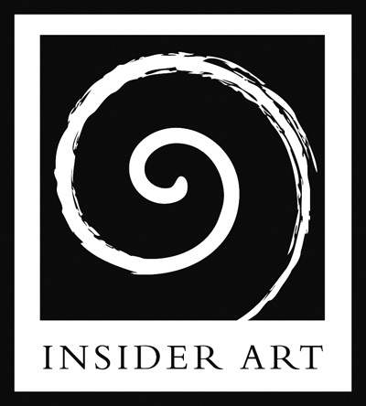
INSIDER ART

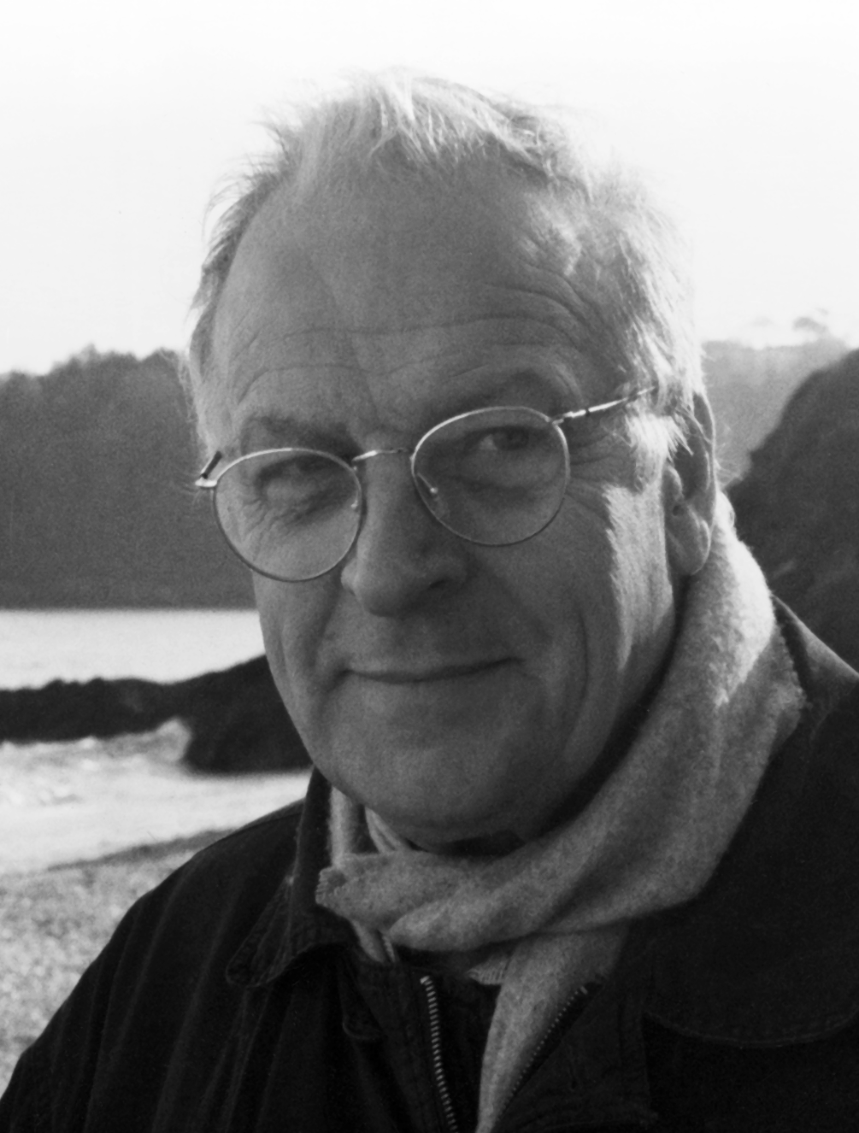

Michael Edwards
1931-2010
CONTENTS
Series Introduction i
About this Book by Professor Shaun McNiff iii
Editors Introduction v
Foreword by Dr Chris Wood xi
Introduction by David MacLagan xvii

Ornithology for the Birds 1
1989 Theme: Public Places Private Faces
The Slippery. 19
1990 Theme: Living the Symbolic Life
Art and Individuation. 41
1991 Theme: Individuation:
With the Flow or Against the Tide?
Chaos 55
1993 Theme: Myth and Meaning
Significant Objects 73
1994 Theme: Sacred and Profane
Where the Lines Meet 89
1995 Theme: The Thread, the Maze and the Minotaur
There’ll be Some Changes Made 109
1996 Theme: Changes
Soul Searching 121
1997 Theme: Living Space Anima Mundi Revisited

Ways In and Ways Out 139
1998 Theme: Harmony and Discord
Without Virtue or Virtuosity 153
1999 Theme: Creation and Human Purpose:
Intentions, Functions and Values.
Mysterious Transactions: Trading Places 161
2000 Theme: Commerce and the Soul.
Drawing the Line 171
2001 Theme: Encompassing Diversity: Living with the Alien
Opening Bars 187
2002 Theme: Negotiating Power
Imagining Reality 201
2003 Theme: Perspective on Relationships:
Connections Disjunctions and the Spaces Between.
Into the Unknown 213
2004 Theme: Significant Transitions: Psychological and
Creative Development.
Bounds of Possibility 223
2005 Theme: Boundaries Borderlines and Crossings

Appendices 239
Appendix One 241
Some Origins of Art Therapy Theory and Practice,
A Jungian Perspective: The Image Is Its Own Best Explanation.
Appendix Two 246
Art Therapy Now. Inscape Volume 5 no: 1. 1981
Appendix Three 257
Jungian Psychology and Particle Physics:
On Synchronicity and the Jung - Pauli Association.
Appendix Four 271
C G Jung Analytical Psychology Club Interview

A Word about the Images 288
Thanks and Acknowledgements 289

ABOUT THIS BOOK
Professor Shaun McNiff

Michael Edwards reflections on art, depth psychology, Jung, therapy and healing, display a keen understanding of each and create a forceful synergy, the likes of which I rarely see and greatly admire. Insider Art are to be thanked for giving this collection a place in our literature. In keeping with the lead metaphor of the book, the ideas have wings that carry the reader inside to the marrow of art and out to the world today, moving in sync with the archetypal mainstream of human experience.

Edwards is a kindred spirit to all of us who honour images and art’s healing powers. Jung is fully aligned with the arts in therapy, all of which can trace their most vital and creative contemporary practices to his exploration of the full spectrum of human expression at the start of the 20th century. His relationship with art and artists, fractured by restrictive statements about the creative process which I have always felt contradict the empirical practice of active imagination, is made whole. The book will appeal to artists looking for a threshold into the arts in therapy which respects the nonlinear depths and transformative crucible of the creative act.

Shaun McNiff is the University Professor at Lesley University in Cambridge, Massachusetts, USA, whose books include: Art Heals: How Creativity Cures the Soul; Art as Medicine: Creating a Therapy of the Imagination; Integrating the Arts in Therapy and Trust the Process: An Artist's Guide to Letting Go.

EDITORS INTRODUCTION

This book, with one exception, consists of previously unpublished papers by Michael Edwards. The majority of these papers were given at an annual summer school dedicated to Jungian psychotherapy and the arts. They had a very limited circulation to attendees of these courses through a privately produced year book. Many of the papers date from Michael’s period as course leader, and were often given on the first evening of the residential course, and sometimes as the last presentation. They were, to borrow one of their titles, ‘Ways in and Ways Out’ of an experience that combined for participants: hands on arts making; arts performances; a sense of community; and talks and presentations exploring from many angles the relationships between creativity and psychotherapy, the individual and the collective. Because the talks related to the course theme chosen each year, we have identified these.

The course had its roots in a radical experiment created by Irene and Gilbert Champernowne at Withymead, near Exeter, Devon from 1942 until late 1960’s. The Withymead community was not only a pioneer in the field of what became the therapeutic communities movement, but also in promoting a more complete integration of the arts and psychotherapy than had ever been attempted before. Michael’s roots as an art therapist and Jungian analyst were in this revolutionary soil. The Champernowne Trust courses were established by Irene after the closure of Withymead. Until his retirement as course leader in 2005, Michael had attended every single one of them.

More can be learned about Withymead in Professor Diane Waller’s, Becoming a Profession: The History of Art Therapy in Britain 1940 - 1982. Tavistock, Routledge, London and New York, 1991, Withymead: A Jungian Community for the Healing Arts Anthony Stevens, Coventure, 1993, and Healing Arts: the History of Art Therapy, Susan Hogan, Jessica Kingsley Publishers, London and Philadelphia, 2001. Michael did not always see entirely eye to eye with these narratives, and something of his own account is included as Appendix Four.
These talks were never intended as academic, or even teaching, exercises. They were frequently elliptical and associative in delivery, and while they embody a great depth of learning about Jungian psychotherapy, art history and the relation between them, it is learning worn lightly. Some of the talks were preserved as written texts: others have been transcribed from tape recordings. The latter contained all the ‘repetitions, deviations and hesitations’ one expects from a verbal delivery. The intention was to either help the listener embark on their own creative journey, or sometimes to help them to return to the mundane world from one. If Michael felt that this transition might be better accomplished by breaking off and playing the trumpet for a few minutes, or looking at clips from Busby Berkeley musicals, or showing one set of images while apparently talking about something else entirely then that is what he would do! Michael never strayed very far from the arts. ‘The arts’, he wrote, ‘give us a peculiarly heightened sense of the thread of life.’

Despite these ‘sleights of hand’ there is always a rich train of thought unfolding through the talks. In editing them we have sought to bring out these threads as clearly as possible, yet retain the warmth and timbre of Michael’s unique voice and way of approaching complexity. He never subscribes to reductionism, maintains a rich range of reference, and genuinely values what is not necessarily reasonable about the arts. With this as his material, the forms are appropriately elliptical and iterative. As approaches to the muses, they are appropriately musing, and sometimes gently amusing. It is a rare combination of subtlety with depth, keen insight, and broad understanding.

Michael’s quality of kind attention, of letting one feel cherished, was at the heart of how he worked as a therapist and as a teacher. It never seemed to occur to him to be the great ‘I AM’ to which his weight and depth might have entitled him.

If Michael wore his authority lightly he often did the same with his clothes. The editors, who enjoyed many years experience of Michael at Cumberland Lodge, shared a private joke that since no shirt could possibly be that crumpled by natural means, Michael must have his own shirt crumpler. We could never quite decide whether it was a device, like a sort of Corby shirt crumpler, or perhaps like poor James Tilly Matthews Air Loom (see page 80), or a personal attendant, a sort of un-butler.

One or both of the editors heard the original presentations of these talks. We hope to have captured something of those experiences, while formalising the referencing, summarising some of the very extensive use of quotation and occasionally distilling some of the material. We have attempted to be thorough in all these tasks: if we have failed to acknowledge or reference accurately we will happily adjust errors in any subsequent edition.

The appendices to the book were not prepared in the context of the Summer courses, but are thematically linked to them. We have been able to include four additional papers:

- A 1981 paper from ‘Inscape’, the Journal of the British Art Therapy Association (and now International Journal of Art Therapy): Art Therapy Now.

- A paper originally prepared for the ‘Fourth Door Review’: Jungian Psychology and Particle Physics.

- A short paper written to accompany a presentation at an Exeter Arts and Therapies Conference in 2007: The Image is its Own Best Explanation.

- An interview with Michael commissioned by ‘Harvest’ magazine in 2003, shedding a very personal light on Michael’s rich professional biography.

As a further supplement to this, we have published (on the Insider Art website: www.insiderart.org.uk) a 1960’s prospectus for Withymead and two of Irene Champernowne’s own seminal papers on the arts and psychotherapy:
Art Therapy as an Adjunct to Psychotherapy (1968)
Art and Therapy: An Uneasy Partnership (1971).
Both of these were also originally published in ‘Inscape’ and are reproduced with permission.
It is a sadness that this book was in preparation over what turned out to be the last few years of Michael’s life, and the task was not quite completed in his lifetime. The last set of proofing drafts had however been brought together into book form, from which Michael derived considerable satisfaction before his death on March 13th, 2010. He especially enjoyed seeing the emerging conversation between word and image in the text. See page 288 for more information about the Thomas Bewick engravings.

Michael's old band-mates saw him off in style with traditional New Orleans Jazz at his funeral: he would have loved that.
Insider Art are honoured to be able to publish this book.
Malcolm Learmonth & Karen Huckvale, 2010

